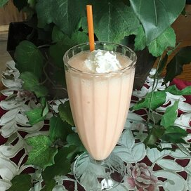

**Orange Milkshake**

**Ingredients:**

1 ½ cups orange juice

2 scoops vanilla ice cream

½ cup milk

**Directions:**

1. Combine orange juice, ice cream, milk, and sugar in a blender; blend until smooth. Pour milkshake into a glass.

**Nutrition Facts (Per Serving)**

Calories 345 Prep: 5 minutes

Protein 8.1 g (16% DV) Total: 5 minutes

Carbohydrates 62.6 g (20% DV) Servings: 1

Fat 7.8 g (12% DV) Yield: 1 milkshake

Cholesterol 28.2 mg (9% DV)

Sodium 87.3 mg (4% DV)